Date: 25/07/25
Roll No. and Name: 24BCE174 and Khush Pithva
Course Code and Name: 2CS502CC25 and Object Oriented Programming
Practical No: 3(a)
AIM: Create overloaded functions named 'area' to compute the area
of a circle, rectangle, and triangle

Methodology followed:
#include <bits/stdc++.h>
using namespace std;
typedef long double ld;

long double area(long double r) {
return 3.14 * r * r;
}
long double area(long double l, long double b) {
return l * b;
}

long double area(long double b, long double h, int) {
return 0.5 * b * h;
}

int main()
{
ld r, l, b, h;

cout << "Enter radius of the circle: ";
cin >> r;
cout << "Area of Circle: " << area(r) << endl;

cout << "Enter length and breadth of the rectangle: ";
cin >> l >> b;
cout << "Area of Rectangle: " << area(l, b) << endl;

cout << "Enter base and height of the triangle: ";
cin >> b >> h;
cout << "Area of Triangle: " << area(b, h, 0) << endl;

return 0;
}
Code using class and objects :
#include <bits/stdc++.h>
using namespace std;
typedef long double ld;

class calculator
{
public:
ld r,l,b,base,h;

ld acircle()
{
return 3.14*r*r;
}

ld arectangle()
{
return l*b;
}

ld atrinagle()
{
return 0.5*base*h;
}
};

int main() {
calculator calc;

cout<<"Enter radius of the circle: ";
cin>>calc.r;
cout<<"Area of Circle: "<<calc.acircle()<<endl;

cout<<"Enter length and breath of the rectangle: ";
cin>>calc.l>>calc.b;
cout<<"Area of Rectangle: "<<calc.arectangle()<<endl;

cout<<"Enter base and height of the triangle: ";
cin>>calc.base>>calc.h;
cout<<"Area of Triangle: "<<calc.atrinagle()<<endl;

return 0;
}

Output:
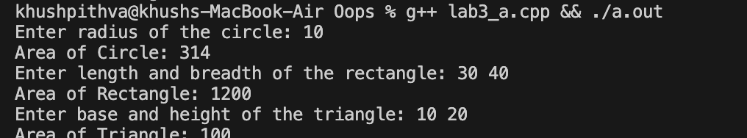
Practical No: 3(b)
AIM: Develop an inline function that returns the cube of a number
and use it with user input.

Methodology followed:
#include <bits/stdc++.h>
using namespace std;
typedef long double ld;

inline int cube(int number) {
return number * number * number;
}

int main()
{
int number;
cout<<"Enter a number : ";
cin>>number;
long long answer = cube(number);
cout<<"Cube of "<<number<<"is :"<<answer;

return 0;
}
Code using class and objects :
#include<bits/stdc++.h>
using namespace std;

class cubes {
public:
int number;
long long cube()
{
return (long long)number*number*number;
}
};

int main()
{
cubes calc;
cout<<"Enter a number: ";
cin >> calc.number;
cout<<"Cube of "<<calc.number<<" is: "<<calc.cube()<<endl;
return 0;
}
Output:
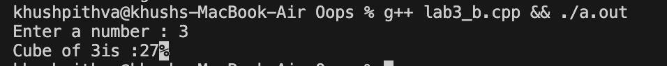
Practical No: 3(c)
AIM: Write overloaded 'display' functions that print an integer, a
float, and a string respectively.

Methodology followed:
#include <bits/stdc++.h>
using namespace std;
typedef long double ld;

void display(int num)
{
cout<<"Integer: "<<num<<endl;
}
void display(float num)
{
cout<<"Float: "<<num<<endl;
}
void display(string text)
{
cout<<"String: "<<text<<endl;
}

int main()
{
int i = 10;
float f = 3.14;
string s = "Khush Pithva";
display(i);
display(f);
display(s);

return 0;
}
Code using class and objects :
#include<bits/stdc++.h>
using namespace std;

class data{
public:
void display(int num)
{
cout << "Integer: " << num << endl;
}

void display(float num)
{
cout << "Float: " << num << endl;
}

void display(string text) {
cout << "String: " << text << endl;
}
};
int main()
{
data obj;
int i = 10;
float f = 3.14;
string s = "Khush Pithva";
obj.display(i);
obj.display(f);
obj.display(s);
return 0;

}

Output:
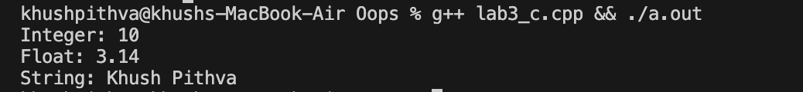
Practical No: 3(d)
AIM: Create a program that uses inline functions to return the
maximum of two numbers.

Methodology followed:
#include<bits/stdc++.h>
using namespace std;

inline int max(int a, int b) {
return (a > b) ? a : b;
}
int main()
{
int a,b;
cout<<"Enter two numbers : ";
cin>>a>>b;

int maximum = max(a,b);

cout << "Maximum of " << a << " and " << b << " is: " << maximum << endl;

}
Code using class and objects :
#include<bits/stdc++.h>
using namespace std;

class maximum{
public:
int num1,num2;
int maxx()
{
return (num1 > num2) ? num1 : num2;
}

};
int main()
{
maximum number;
cout<<"Enter two number : ";
cin>>number.num1>>number.num2;

cout << "Maximum of " << number.num1 << " and " << number.num2 << " is: " << number.maxx() << endl;
return 0;

}

Output:
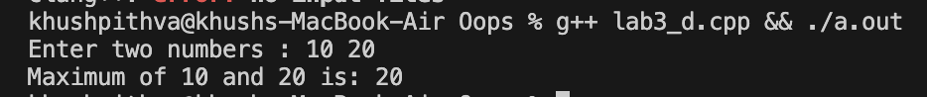
Practical No: 3(e)
AIM: Develop a program that uses function overloading for
summing two and three double values.
Methodology followed:
#include <bits/stdc++.h>
using namespace std;

long double sum(long double a, long double b)
{
return a + b;
}
long double sum(long double a, long double b, long double c)
{
return a + b + c;
}

int main() {
long double x,y,z;
cout<<"Enter 3 numbers : ";
cin>>x>>y>>z;
cout<<"Sum of "<<x<<" and "<<y<<" is: "<<sum(x, y)<<endl;
cout<<"Sum of "<<x<<", "<<y<<" and "<<z<<" is: "<<sum(x, y, z)<<endl;

return 0;
}
Code using class and objects :
#include <bits/stdc++.h>
using namespace std;

class summ{
public:
int num1,num2,num3;
int sum2()
{
return num1+num2;
}
int sum3()
{
return num1+num2+num3;
}

};

int main()
{
summ number;
cout<<"Enter 3 numbers : ";
cin>>number.num1>>number.num2>>number.num3;
cout<<"Sum of first 2 number is "<<number.sum2()<<endl;
cout<<"Sum of first 2 number is "<<number.sum3()<<endl;
return 0;
}

Output: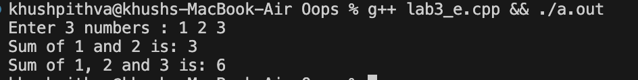
Conclusion:
This practical helped us understand function overloading and inline functions in C++. These concepts improve code readability, reusability, and performance in modular programming.

